Name: Arya Shailesh Vast
PGD Bioinformatics, St. Xavier’s College

Assignment: Differential Gene Expression Analysis Using Publicly Available Transcriptomic Data in Neurological Disorders
- Dataset Search and Selection:
GEO Accession | GSE38417
Disorder | Duchenne Muscular Dystrophy (rare neuromuscular disorder)
Organism | Homo sapiens
Sample Type | Muscle biopsy
Platform | Affymetrix Human Genome U133 Plus 2.0
Disease Samples | Duchenne Muscular Dystrophy (DMD) patients
Control Samples | Pathologically normal muscle

- Aim: To identify genes that are differentially expressed between Duchenne muscular dystrophy patients and healthy controls using public transcriptomic data.

- Objectives:
- To retrieve the Duchenne muscular dystrophy gene expression dataset (GSE38417) from the GEO database using R.
- To extract and organize the expression matrix and sample metadata for disease and control groups.
- To perform differential gene expression analysis between Duchenne muscular dystrophy and healthy control samples using the limma package.
- To identify statistically significant genes based on log₂ fold change and adjusted p-value thresholds.
- To visualize the differential gene expression results using a volcano plot.

- Experimental design of the selected dataset : Skeletal muscle biopsy samples were obtained from boys diagnosed with Duchenne muscular dystrophy and from pathologically normal controls. RNA was extracted from each biopsy and hybridized to Affymetrix Human Genome U133 Plus 2.0 microarrays to measure genome-wide gene expression. The experimental design consisted of a case–control comparison between DMD patients and healthy individuals to identify differentially expressed genes associated with the disease.

- Definition of the disease and control groups used for comparison.
Group | Definition
Disease | Muscle biopsies from Duchenne muscular dystrophy patients
Control | Muscle biopsies from pathologically normal individuals

- Justification of the data selected: GSE38417 is a well-annotated human transcriptomic dataset from a rare neuromuscular disease. It includes clearly defined disease and control samples analysed on a standardized microarray platform, making it statistically and biologically suitable for differential gene expression analysis.

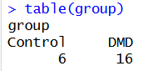
- Differential gene expression analysis between disease and control samples using R software.

Differential gene expression analysis was carried out in R using the Bioconductor package limma. The dataset GSE38417 was imported and samples were classified into Duchenne muscular dystrophy (DMD) and control groups based on metadata. A total of 22 samples were analysed, including 16 DMD and 6 control samples.
A design matrix was created to compare the two groups, and a statistical model was used to identify genes that were expressed differently between DMD and control samples. Genes were considered significant based on their log₂ fold change and adjusted p-values.

- Volcano plot representing differential gene expression of the selected data: A volcano plot was used to display the differential gene expression results. It shows the log₂ fold change on the x-axis and the statistical significance (−log₁₀ adjusted p-value) on the y-axis. Each point represents a gene, and genes with large expression changes and strong statistical significance appear at the top left and top right of the plot. Significant genes (|log₂FC| > 1, adjusted p < 0.05) were highlighted to distinguish them from non-significant ones.
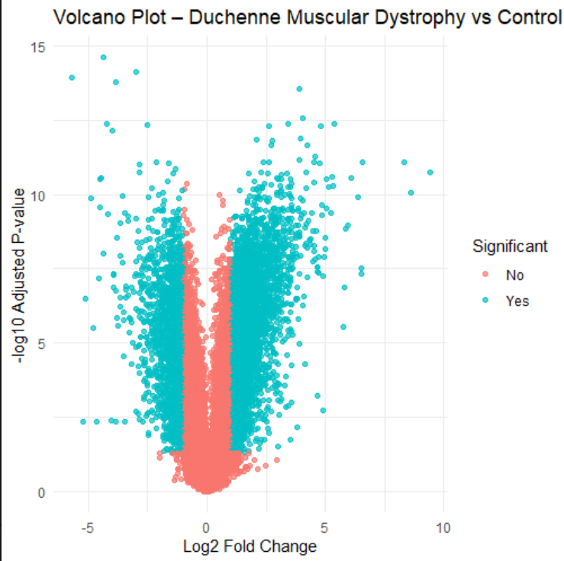
Figure 1: Volcano plot showing differentially expressed genes between Duchenne muscular dystrophy patients and healthy controls. The x-axis represents log₂ fold change, while the y-axis represents −log₁₀ adjusted p-values. Blue points indicate significantly dysregulated genes (|logFC| > 1, FDR < 0.05)

Appendix – R Code
rm(list=ls())
gc()
install.packages(c("rlang","vctrs","scales","gtable","ggplot2"), type="binary")
library(GEOquery)
library(limma)
library(Biobase)
library(ggplot2)
gset <- getGEO("GSE38417", GSEMatrix=TRUE)[[1]]
expr <- exprs(gset)
pdata <- pData(gset)
group <- ifelse(grepl("dystrophy", pdata$characteristics_ch1, ignore.case=TRUE),
"DMD", "Control")
group <- factor(group)
table(group)
design <- model.matrix(~0+group)
colnames(design) <- levels(group)
fit <- lmFit(expr, design)
contrast <- makeContrasts(DMD-Control, levels=design)
fit2 <- contrasts.fit(fit, contrast)
fit2 <- eBayes(fit2)
deg <- topTable(fit2, number=Inf)
head(deg)
write.csv(deg, "DMD_DEG_results.csv")
deg$Significant <- ifelse(deg$adj.P.Val < 0.05 & abs(deg$logFC) > 1,
"Yes", "No")
library(ggplot2)
ggplot(deg, aes(logFC, -log10(adj.P.Val), color=Significant)) +
geom_point(alpha=0.7) +
theme_minimal() +
labs(
title="Volcano Plot – Duchenne Muscular Dystrophy vs Control",
x="Log2 Fold Change",
y="-log10 Adjusted P-value"
)
ggsave("Volcano_DMD.png", width=7, height=5)

